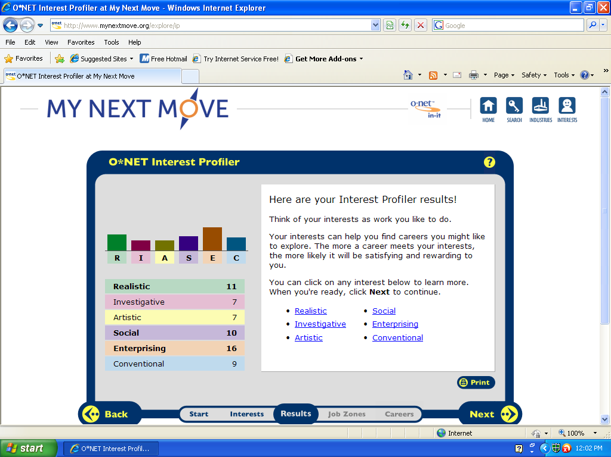Ricky Rose
I agree with this survey because some of the suggested jobs might be something that I will look in to after high school. But there is something’s that I am simply not interested in researching or as a career.

Realistic
Personality | Work Environments | Sample Occupations | Sample College Majors
prefers to work with things  present oriented  structured patterns of thoughts  mechanical  athletic  persistent | technical / mechanical  production oriented  hands-on tasks  industrial  outdoors | Animal Caretakers (RCE)  Drywall Installers (RCE)  Heating/Air Refrigerator Mechanics (REC)  Auto Mechanics (RES)  Cooks (RSE)  Electricians/Electrical Engineering Technicians (RES)  Printing Machine Operators (RIC) | Welding (REI)  Animal Care Technology (REI)  Heating/Air Technology (RES)  Forestry (REI)  Marine Technology (REA)  Building Construction Technology (RIE)  Robotic Technology (RIS)  Electrical Engineering (RIE)

Enterprising
Personality | Work Environments | Sample Occupations | Sample College Majors
adventurous  leadership  persuasive  value political & economic matters | managerial roles in organizations  business driven  entrepreneurial  rewards monetary gains & achievements | Lawyers (ESA)  Sales Representatives (ESA)  Public Relations Specialist (ESA)  Financial Analyst (ESC)  Travel Agents (ESA)  Flight Attendants (ESC)  Hairdressers/Cosmetologist (ESR)  Reporters (EAS) | Banking & Finance (ESR)  Fashion Merchandising & Marketing (ESA)  Food Service Management (ESC)  Hospitality/Tourism (ESR)  Business Administration (ESC)  Personnel Management (ESR)  Hotel & Restaurant Management (ESR)
WHAT I WANNA BE
- Cop
- EMT
- Jailer
- Mechanical engineering
- Aircraft mechanic
- Power plant operator
- Judge

- Cop
HR1. What is the definition of each occupation that your group has chosen and the nature of the work?
- Police officers and detectives enforce laws, They catch criminals. They collect evidence, sometimes testify in court
HR2. What are some of the related occupational fields?
- detectivesCorrectional officers Customs and immigration inspectors Firefighting occupations Private detectives and investigators Security guards
HR3. Which personality type(s) is best suited to the occupations/jobs you have researched?
- They must be healthy, strong, and of good character.
HR4. What kind of education, training and qualifications are required?
-Some local, special, and State police units want recruits to have some college training.
HR5. What technology skills are needed to be successful in the career/occupational fields you have explored?
-basic computer skills.
RC1. What does each occupation pay, or what are the average earnings nationally and in this area of the country?
-average yearly wages of $52,810
RC2. What is the projected growth for this career field over the next 10 years? (i.e. will there be more or less jobs like this in the future?)
-Employment of police officers and detectives is expected to increase about as fast as the average for all occupations through 2018
RC3. Please identify local or national organizations that would hire someone in each career field you have explored.
-Almost 9 out of 10 worked for local government. The rest worked for state or federal police agencies.
ISC1. What are the working conditions or work environment for each job you or your group decided to research (such as work schedule, hours, exempt/salaried or non-exempt/hourly, etc.)?
-detectives work at least 40 hours a week, some police have to work nights and weekends, Some have to travel a lot, often on short notic.
ISC2. Are positions in this career field typically part of collective bargaining units (unions)?
-yes
ISC3. What kind of opportunities for advancement are there for each career? (i.e. Is there a chance to get promoted, etc.?)
-Police officers usually become eligible for promotion after a probationary period ranging from 6 months to 3 years

- EMT

HR1. What is the definition of each occupation that your group has chosen and the nature of the work?

- emergency medical technicians (EMTs) and paramedics
HR2. What are some of the related occupational fields?

- Police and fire fighters
HR3. Which personality type(s) is best suited to the occupations/jobs you have researched?
-be able to act quickly under pressur. emotionally stable, have good dexterity, agility, and physical coordination, and be able to lift and carry heavy loads
HR4. What kind of education, training and qualifications are required?
- A high school diploma is usually required to enter a formal emergency medical technician training program. Training is offered at progressive levels: EMT-Basic, EMT-Intermediate, and Paramedic.
HR5. What technology skills are needed to be successful in the career/occupational fields you have explored?
- need to have the basic skills on computer and

RC1. What does each occupation pay, or what are the average earnings nationally and in this area of the country?

- $44,410ish
RC2. What is the projected growth for this career field over the next 10 years? (i.e. will there be more or less jobs like this in the future?)
-
RC3. Please identify local or national organizations that would hire someone in each career field you have explored.

ISC1. What are the working conditions or work environment for each job you or your group decided to research (such as work schedule, hours, exempt/salaried or non-exempt/hourly, etc.)?
ISC2. Are positions in this career field typically part of collective bargaining units (unions)?
-yes
ISC3. What kind of opportunities for advancement are there for each career? (i.e. Is there a chance to get promoted, etc.?)

- Jailer
HR1. What is the definition of each occupation that your group has chosen and the nature of the work?
-May guard prisoners in transit between jail, courtroom, prison, or other point.
HR2. What are some of the related occupational fields?
- cop
HR3. Which personality type(s) is best suited to the occupations/jobs you have researched?
-
HR4. What kind of education, training and qualifications are required?
- High school diploma
HR5. What technology skills are needed to be successful in the career/occupational fields you have explored?

RC1. What does each occupation pay, or what are the average earnings nationally and in this area of the country?
-39,000$ 52,000$
RC2. What is the projected growth for this career field over the next 10 years? (i.e. will there be more or less jobs like this in the future?)
RC3. Please identify local or national organizations that would hire someone in each career field you have explored.
ISC1. What are the working conditions or work environment for each job you or your group decided to research (such as work schedule, hours, exempt/salaried or non-exempt/hourly, etc.)?
ISC2. Are positions in this career field typically part of collective bargaining units (unions)?
ISC3. What kind of opportunities for advancement are there for each career? (i.e. Is there a chance to get promoted, etc.?)

4) Mechanical engineering

HR1. What is the definition of each occupation that your group has chosen and the nature of the work?
HR2. What are some of the related occupational fields?
Aerospace product manufacturer, federal executive branch, power transmissions equipment manufacturer
HR3. Which personality type(s) is best suited to the occupations/jobs you have researched?
HR4. What kind of education, training and qualifications are required?
HR5. What technology skills are needed to be successful in the career/occupational fields you have explored?

RC1. What does each occupation pay, or what are the average earnings nationally and in this area of the country?
RC2. What is the projected growth for this career field over the next 10 years? (i.e. will there be more or less jobs like this in the future?)
RC3. Please identify local or national organizations that would hire someone in each career field you have explored.

ISC1. What are the working conditions or work environment for each job you or your group decided to research (such as work schedule, hours, exempt/salaried or non-exempt/hourly, etc.)?
ISC2. Are positions in this career field typically part of collective bargaining units (unions)?
ISC3. What kind of opportunities for advancement are there for each career? (i.e. Is there a chance to get promoted, etc.?)

Analysis of Career Research Data

